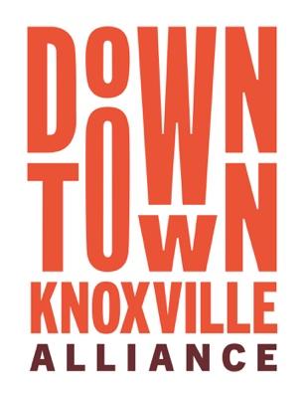
Downtown Knoxville Alliance
Sponsorship Request Application

The goal of the Downtown Knoxville Alliance Sponsorship Program is to help support events that add to the vibrancy and enjoyment of Downtown Knoxville. The program is focused on supporting new events as they establish additional community support and funding, as well as established events that bring more people to Downtown Knoxville to work, live, shop and play.

Event Date(s) | Application Due
January, February | November 1
March, April | January 1
May, June | March 1
July, August | May 1
September, October | July 1
November, December | September 1

The application must include a projected budget (including detailed income and expenses), information on how the event will be promoted, information on how the event positively impacts Downtown Knoxville (including residents, businesses, or visitors), and proof of nonprofit status if applicable. Previous three-year actual income and expenses for the event should also be submitted if applicable.

Sponsorship Guidelines:

- All events are evaluated based on current merits, regardless of funding in the past.

- Preference will be given to events, segments of events, and activities that are free and provide reasonably widespread public access and benefit, although exceptions may be made if circumstances warrant.

- Paid ticketed events, for-profit, or fund-raising events are typically not considered.

- The Downtown Knoxville Alliance strives to distribute sponsorships equitably to events throughout the central business district (e.g., World’s Fair Park, Market Square, Volunteer Landing, Old City, Gay Street, Union Ave, etc.) and throughout the calendar year. Preference will be given to locations and times that have not historically had significant programming.

- As a general rule, sponsorships will not exceed 20% of total event expenses.

- Sponsorships are awarded based on the merits of a stand-alone event. Therefore, a single organization can submit and receive approval for multiple events throughout the year.

Requirements:

- Sponsored events should include the Downtown Knoxville Alliance as a sponsor in all pre-event publicity, marketing materials, websites, posters, and event materials. Information on downtown parking should also be included.

- A post-event evaluation is required within 45 days of the event. Payments will be made in two parts. One-half will be paid prior to the event and the balance will be paid upon receipt of the completed post-event evaluation. Refunds will be requested for any events that are cancelled. Final payment will be forfeited if post-event evaluation is not received.

Completed applications should be emailed to rthomas@downtownknoxville.org, mailed or delivered to Downtown Knoxville Alliance, Attn: Robin Thomas, 17 Market Square, Knoxville, TN 37902. For questions, call 865.246.2653.
Downtown Knoxville Alliance
Sponsorship Request Application

Event:

Date(s):

Location:

Produced by:

Sponsorship amount requested: ___________________

Event History:

____ First-time event (#) ____ prior years (#) ____ years of previous Alliance funding

Contact: Phone: ________________________________

Address:

Email:

Event description:

Additional sponsors:

Planned use of funds requested:

What is the projected attendance for this event? How will actual attendance be measured? Describe the demographics of anticipated attendees.

What opportunities, if any, will be provided for downtown merchants to participate?

How will this event positively impact downtown?

What effect would lack of Downtown Knoxville Alliance funding have on this event?

Attach the following:

Projected budget, including detailed income and expenses
Detailed marketing and promotion plans
Previous three-year actual financial results (if applicable)
Proof of nonprofit status (if applicable)

